**Agriculture Recommendation System using Machine Learning**

BACHELOR OF COMPUTER ENGINEERING

by

**Avishkar Dalvi (﻿20202002)**

**Riddhi Narkar (19102003)**

**Radha Rakshe (19102067)**

**Aarya Totey (﻿19102070)**

Guide

Prof. Deepak Khachane



Department of Computer Engineering

A. P. SHAH INSTITUTE OF TECHNOLOGY, THANE

2022-2023



A. P. SHAH INSTITUTE OF TECHNOLOGY, THANE

CERTIFICATE

This is to certify that the project entitled “**Agriculture Recommendation System using Machine Learning**” is a bonafide work of“**Avishkar Dalvi” (﻿20202002), “Riddhi Narkar” (19102003), “Radha Rakshe” (19102067), “Aarya Totey” (﻿19102070)** submitted to the University of Mumbai in partialfulfilment of the requirement for the award of the degree of **Bachelor of Engineering in Computer Engineering.**

**________________________________ __________________________________**

Guide Project Coordinator

Prof. Deepak Khachane Prof. Rushikesh Nikam

_______________________ ______________________

Head of Department Principal

Prof. Sachin Malave Dr. Uttam Kolekar

Date:

 A. P. SHAH INSTITUTE OF TECHNOLOGY, THANE

**Project Report Approval for B.E.**

This project report for Sem-VII entitled ***Agriculture Recommendation System using Machine Learning by “Avishkar Dalvi” (﻿20202002), “Riddhi Narkar” (19102003), “Radha Rakshe” (19102067), “Aarya Totey” (﻿19102070) is approved for the degree of Bachelor of Engineering in Computer Engineering, 2022-23.***

Examiner Name Signature

1. ___________________________

2. ___________________________

Date:

Place:

**Declaration**

We declare that this written submission represents my ideas in my own words and where others' ideas or words have been included, I have adequately cited and referenced the original sources. I also declare that I have adhered to all principles of academic honesty and integrity and have not misrepresented or fabricated or falsified any idea/data/fact/source in my submission. I understand that any violation of the above will be cause for disciplinary action by the Institute and can also evoke penal action from the sources which have thus not been properly cited or from whom proper permission has not been taken when needed.

Avishkar Dalvi (﻿20202002)

Riddhi Narkar (19102003)

Radha Rakshe (19102067)

Aarya Totey (﻿19102070)

Date:

**Abstract**

*India is an agrarian society. Majority of our population is involved in agriculturally based activities and are dependent on crops related business for their livelihood. Farmers often are not able to produce a good yield due to poor farming decisions. This works aims to be an assistance tool for a farmer to make his farming decisions. It comprises of three machine learning models namely a crop recommendation system, a fertilizer recommendation system, and a crop disease identification system with cures for the diseases. The crop recommendation and the fertilizer recommendation use regression models whereas the crop disease identification uses convolutional neural network model.*

**CONTENTS**

1. Introduction 1
2. Literature Survey 5
3. Limitation of Existing System 13
4. Problem Statement, Objectives and Scope 15

4.1 Problem Statement 15

4.2 Objective 16

4.3 Scope 16

1. Proposed System 17

5.1 Project Design 17

5.2 Implementation Details 23

1. Experimental Setup 25
2. Project Plan 27
3. Expected Outcome 29

References 31

**LIST OF FIGURES**

5.1 Architecture Diagram ..................................................................................17

5.2 DFD level 0 ..................................................................................................18

5.3 DFD level 1 ..................................................................................................18

5.4 Use case diagram .........................................................................................19

5.5 Sequence Diagram .......................................................................................21

5.6 Activity Diagram .........................................................................................22

5.7 Implementation Details.................................................................................23

7.1 Gantt Chart ...................................................................................................27

**LIST OF TABLES**

2.1 Literature Survey .........................................................................................7

**Abbreviation**

|  |  |
| --- | --- |
| *ICT* | Information Communication Technology |
| *ML* | Machine Learning |
| *DL* | Deep Learning |
| *CNN* | Convolutional Neural Networks |
| *LVQ* | Learning Vector Quantization |

**CHAPTER 1**

**Introduction**

India has a primary sector economy, that means that majority of our population is involved in agriculturally based activities and are dependent on crops related business for their livelihood. ﻿As per the census in 2011; in India, approximately 118 million people are farmers and 144 billion people are laborers working in an agricultural field [1]. Total Indian population of India in 2011 was nearly about 121 crore and out of which nearly about 2630 lack people are farmers [1]. This makes India, an agrarian society. With the production of agriculture activity of $375.61 billion, India is 2nd larger producer of agriculture products [1]. India accounts for 7.39 percent of total global agricultural output [1]. India’s economy is being driven by majority of the population engaging in primary sector occupations. The Agriculture sector’s contribution to the Indian economy is much higher than the world’s average (6.4%). The industry and services sector’s contribution is lower than the world’s average 30% for the Industry sector and 63% for the Services sector [1].

The Government of India, since its inception in 1947, has being running huge and many schemes that help farmers. For example, the “Parampragat Krishi Vikas Yojana (PKVY)” which is one of the important government schemes which encourages farmers for traditional and organic farming in India. Under this scheme, the Government of India provides a financial assistance to the farmers of Rs 50,000 per hectare every three years for organic inputs, certification, labelling, packaging, transportation and marketing of organic produce. The scheme focuses on reducing the ill effects of overuse of fertilisers and agrochemicals by promoting organic manures, bio-fertilisers and bio-pesticides. It helps improve the soil fertility by improving organic carbon in the soil which results in enhancing moisture holding capacity in the field too.

In spite of many such schemes, the factor that hurts the farmer more is the unpredictable weather conditions and poor planning for harvest. Multiple unsustainable technologies took a huge toll on our Earth in the recent past decades giving rise to global warming and climate as worldwide crisis. Lal Bahadur Shastri once said, “Jai Jawan Jai Kisaan”, which believed in uplifting the role of a farmer. Through the course of this work, we noticed that ICT can help farmers. ICT in agriculture is an emerging field focusing on the enhancement of agricultural and rural development in India [2]. It involves innovative applications using ICT in the rural domain [2]. The advancement of ICT can be utilized for providing accurate and timely relevant information and services to the farmers, thereby facilitating an environment for remunerative agriculture [2].

Crop diseases are a major threat to food security, but their rapid identification

remains difficult in many parts of the world due to the lack of the necessary infrastructure. The combination of increasing global computer penetration and recent advances in computer vision made possible by deep learning has paved the way for disease diagnosis.[4]

Crop cultivation anywhere in the world depends on the climate so called seasons and soil properties, however, the enhancing the production of crops depend on various factors like mainly on temperature. The ideal harvest prior to planting it, it would be of extraordinary assistance to the farmers and others required to settle on fitting choices on upgrading the creation of yields for neighborhood utilization needs and may prompt the capacity and expanded fare choice for business. For that, ML procedures with the end goal that it proposes the appropriate corps dependent on the temperature.

Most of the farmers are untutored and have little to no scientific knowledge of farming. So, they have to rely on the hit and trial method to learn from experience which leads to wastage of time and resources. We need a system to focus on building a predictive model to recommend the most suitable crops to grow in a particular farm based on various parameters. This can be helpful for the farmers to be more productive and competent without wasting any resources by farming the most competent crops.

With the vision of providing assistance and guidance to farmers during the crucial decision-making process required at various stages during farming, we propose a solution in the form of three ML models. Under many government schemes, farmers are able to get their land tested for nutrients. A farmer has all the lab results, but is not able to turn those results into actions and implementation. This work bridges that gap.

This work determines to assist and guide the farmers in 3 important and crucial areas of agricultural decisions, namely, which crop to be planted and which fertilizer to be used, both of which pertaining to the soil and weather conditions; and the last one to predict plant diseases and provide the farmer with organic solutions for the same as well.

**CHAPTER 2**

**Literature Survey**

1. AI based automatic Crop Disease Detection System, IEEE Xplore

Crop production is affected by number of diseases worldwide. Timely detection of diseases will allow to monitor and implement control measures with greater efficiency. The main aim of this project is to design an AI-Based disease detection system that detects the type of disease present in tomato leaf by clicking the images of various leaves through camera and spray the respective pesticide to the diseased part of the plant.

# Identification of Plant Diseases Using Image Processing, IEEE Xplore

# In the field of agriculture, image processing is a constantly evolving field of research and progress. Currently, several plant disease identification studies are underway. Identifying plant diseases can not only help farmers increase yields, but also promote a variety of agricultural practices. This paper proposes an algorithmic program for the disease detection and categorization with the assistance of machine learning mechanisms and image recognition tools.

1. Plant Leaf Disease Detection and Classification based on CNN with LVQ algorithm, IEEE Xplore

The early detection of diseases is important in agriculture for an efficient crop yield. Automatic methods for classification of plant diseases also help taking action after detecting the symptoms of leaf diseases. This paper presents a Convolutional Neural Network (CNN) model and Learning Vector Quantization (LVQ) algorithm based method for tomato leaf disease detection and classification.

1. Machine Learning based Crop Recommendation System for Local Farmers of Pakistan

It has been a major problem to identify what to grow, any man has adequate space in the owner’s land. Not only domestic lands but also for farming lands. Why it has become a problem is that environmental factors such as temperature, water levels, and soil conditions are uncertain as they change from time to time. Due to these problems, this solution of crop recommendation system predicts the user, what crop type would be the most suitable for the selected area by collecting the environmental factors for plant growth and processing them with the trained sub-models of the main of the system.

1. Using Deep Learning for Image-Based Plant Disease Detection

Crop diseases are a major threat to food security, but their rapid identification

remains difficult in many parts of the world due to the lack of the necessary

infrastructure. The combination of increasing global smartphone penetration and recent advances in computer vision made possible by deep learning has paved the way for smartphone-assisted disease diagnosis.

1. Machine Learning Based Crop Recommendation System

This system focuses on building a predictive model to recommend the most suitable crops to grow in a particular farm based on various parameters. This can be helpful for the farmers to be more productive and competent without wasting any resources by farming the most competent crops.

1. Crop Recommendation System

Recommendation system through integrated models of collecting environmental factors using Arduino microcontrollers, Machine learning techniques such as Naïve Bayes (Multinomial) and Support Vector Machine (SVM), Unsupervised machine learning algorithm such as K-Means Clustering and also Natural Language Processing (Sentiment Analysis) concerned with the Artificial Intelligence to recommend a crop for the selected land with site-specific parameters with high accuracy and efficiency. It has been a major problem to identify what to grow, any man has adequate space in the owner’s land. Not only domestic lands but also for farming lands.

|  |  |  |  |
| --- | --- | --- | --- |
| **Title of the research paper** | **Year published** | **Authors** | **Abstract** |
| AI Based Automatic Crop Disease Detection System **IEEE Xplore** | 2021 | Sunidhi N, Jalaja S  VLSI Design and Embedded Systems Bangalore Institute of Technology, Bangalore, India;  Dept. of Electronics and Communication, Bangalore Institute of Technology, Bangalore, India | Timely detection of diseases will allow to monitor and implement control measures with greater efficiency. The main aim of this project is to design an AI-Based disease detection system that detects the type of disease present in tomato leaf by clicking the images of various leaves through camera and spray the respective pesticide to the diseased part of the plant. Deep Convolutional neural networks (D-CNN) and transfer learning techniques are used to detect and classify the disease. Three transfer-learning models i.e., Alex Net, InceptionV3 and ResNet152V2 were used for training and classification and the results were compared which gave the accuracy of 95%, 97% and 99% respectively. |
| Identification of Plant Diseases Using Image Processing and Image Recognition **IEEE Xplore** | 2021 | V Rajesh Kumar, K Pradeepan,  S Praveen,  M Rohith,  V Vasantha Kumar  Department of Computer Science and Engineering, KCG College of Technology, Chennai, India | In the field of agriculture, image processing is a constantly evolving field of research and progress. Currently, several plant disease identification studies are underway. Identifying plant diseases can not only help farmers increase yields, but also promote a variety of agricultural practices. This paper proposes an algorithmic program for the diseases detection and categorization with the assistance of machine learning mechanisms and image recognition tools. First detect and record the contaminated area and then perform image pre-processing. |
| Plant Leaf Disease Detection and Classification based on CNN with LVQ algorithm  **IEEE Xplore** | 2020 | ﻿  Melike Sardogan, Adem Tuncer, Yunus Ozen  Department of Computer Engineering, Yalova University | ﻿  The early detection of diseases is important in agriculture for an efficient crop yield. The bacterial spot, late blight, Septoria leaf spot and yellow curved leaf diseases affect the crop quality of tomatoes. Automatic methods for classification of plant diseases also help taking action after detecting the symptoms of leaf diseases. This paper presents a Convolutional Neural Network (CNN) model and Learning Vector Quantization (LVQ) algorithm based method for tomato leaf disease detection and classification. The dataset contains 500 images of tomato leaves with four symptoms of diseases. We have modelled a CNN for automatic feature extraction and classification. |
| ﻿  Crop Recommendation System  **﻿International Journal of Computer Applications (0975 – 8887)**  **Volume 175– No. 22, October 2020** | 2020 | **﻿**  Pradeepa Bandara,  Thilini Weerasooriya,  Ruchirawya T.H.,  W.J.M. Nanayakkara,  Dimantha M.A.C,  Pabasara M.G.P.  Sri Lanka Institute of Information Technology, Sri Lanka | ﻿  Recommendation system through integrated models of collecting environmental factors using Arduino microcontrollers, Machine learning techniques such as Naïve Bayes (Multinomial) and Support Vector Machine (SVM), Unsupervised machine learning algorithm such as K-Means Clustering and also Natural Language Processing (Sentiment Analysis) concerned with the Artificial Intelligence to recommend a crop for the selected land with site-specific parameters with high accuracy and efficiency. It has been a major problem to identify what to grow, any man has adequate space in the owner’s land. |
| ﻿  Using Deep Learning for  Image-Based Plant Disease  Detection  Frontiers in Plant Science Online Publication | 2019 | ﻿﻿  Sharada P. Mohanty, David P. Hughes, and Marcel Salathé  ﻿Digital Epidemiology Lab, EPFL, Geneva, Switzerland, School of Life Sciences, EPFL, Lausanne, Switzerland. | ﻿﻿  Crop diseases are a major threat to food security, but their rapid identification  remains difficult in many parts of the world due to the lack of the necessary  infrastructure. Using a public dataset of 54,306 images of diseased and healthy plant leaves collected under controlled conditions, we train a deep convolutional neural network to identify 14 crop species and 26 diseases (or absence thereof). The trained model achieves an accuracy of 99.35% on a held-out test set, demonstrating the feasibility of this approach. |
| ﻿  Machine Learning based Crop Recommendation System for Local Farmers of Pakistan  A Research Gate Preprint Online Publication | 2021 | ﻿  Sayed Mazhar Ali,  Bhagwan Das,  Dileep Kumar  Department of Electronic Engineering, Quaid  University of Engineering, Science and Technology, Nawabshah, Sindh, Pakistan. | ﻿  In Pakistan, the most part of the land is used for agriculture cultivation to meet the desires of nearby people and export want as properly. Crop cultivation anywhere in the world depends on the climate so called seasons and soil properties, however, the enhancing the production of crops depend on various factors like mainly on temperature. In order to address the issue of increasing crop production for Pakistan, a crop recommendation system is proposed in this work. In this work, idea of ideal harvest prior to planting it, it would be of extraordinary assistance to the farmers and others required to settle on fitting choices on upgrading the creation of yields for neighborhood utilization needs and may prompt the capacity and expanded fare choice for business. subsequently diminishes the monetary misfortunes looked by the farmers. |
| ﻿﻿  Machine Learning Based Crop Recommendation System  ﻿International Journal of Advanced Research in Science, Communication and Technology | 2021 | ﻿  Dhruv Piyush Parikh,  Jugal Jain, Tanishq Gupta, Rishit Hemant Dabhade  ﻿Vellore Institute of Technology,  VIT Chennai, India | ﻿﻿  The three most basic amenities required for the survival of a human being are food, shelter and clothing. In today’s tech-savvy generation, the latter two have witnessed a huge scientific boost. Unfortunately, even today, agriculture is considered as more of a man-power oriented field. Most of the farmers are untutored and have little to no scientific knowledge of farming. So, they have to rely on the hit and trial method to learn from experience which leads to wastage of time and resources. Our system focuses on building a predictive model to recommend the most suitable crops to grow in a particular farm based on various parameters. This can be helpful for the farmers to be more productive and competent without wasting any resources by farming the most competent crops. |

Table 2.1 Literature Survey

**CHAPTER 3**

**Limitation of Existing system**

After the study of all the aforementioned works, we found 3 key limitations:

1. Absence of a unified product/service to solve problem
2. Products/services demanding a high computer literacy rate to be used by farmers
3. Lack of solution based approach in products/services with a classification or an identification system

**CHAPTER 4**

**Problem Statement, Objectives and Scope**

**4.1 Problem Statement**

To implement a system for farmers with features of crop recommendation, fertilizer recommendation, and crop leaf disease identification.

As easy as it might be to be a city dweller, we cannot ignore to the plights of our farmers. India has a primary sector economy, that means that majority of our population is involved in agriculturally based activities and are dependent on crops related business for their livelihood. India, no doubt is an agrarian society, and we often tend to ignore this fact.

Multiple unsustainable technologies took a huge toll on our Earth in the recent past decades giving rise to global warming and climate as worldwide crisis. This hurts the farmer the most, as they are often lacking proper guidance and resources to solve their problems. Lal Bahadur Shastri once said, “Jai Jawan Jai Kisaan”, which believed in uplifting the role of a farmer.

This project is aimed at assisting the farmer by deploying a crop recommendation system, a fertilizer recommendation system, and a crop disease identification system with cures. All these would be implemented as three different ML models and integrated into a single webpage for easier and convenient access.

**4.2 Objectives**

The objectives of this work include:

1. To provide a single place to access help for crop related problems, the causes, and how to cure them, thus providing a solution-based approach
2. To make these services available over the internet in order to maximize reach
3. To try to make the UI as simple as possible so that a naïve user, whose computer literacy is lower than average, too, can easily navigate

**4.3 Scope**

The scope of this work includes:

1. This project has the potential to assist a farming enthusiast or an occupational farmer to make smarter decisions on his harvest strategy
2. It can provide necessary guidance related to cultivation and fertilizer ideas and curing crop diseases

**CHAPTER 5**

**Proposed System**

**5.1 Project Design**

5.1.1 Architecture diagram

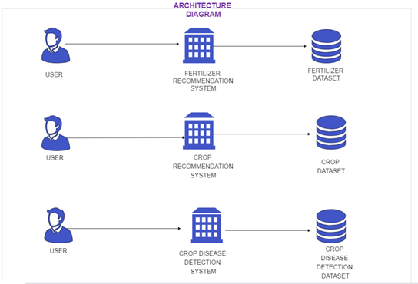

Fig 5.1 Architectural diagram

An architectural diagram is a visual representation that maps out the physical implementation for components of a software system. It shows the general structure of the software system and the associations, limitations, and boundaries between each element.

This architectural diagram depicts how the three ML models are being deployed. Each has its own dataset and the user needs to invoke a different request for each service.

* + 1. DFD

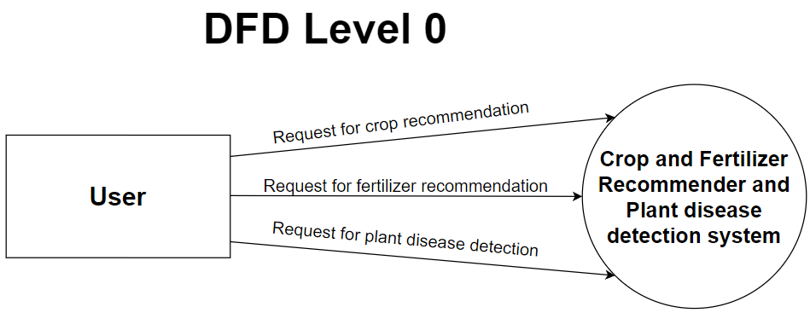

Fig 5.2 DFD level 0

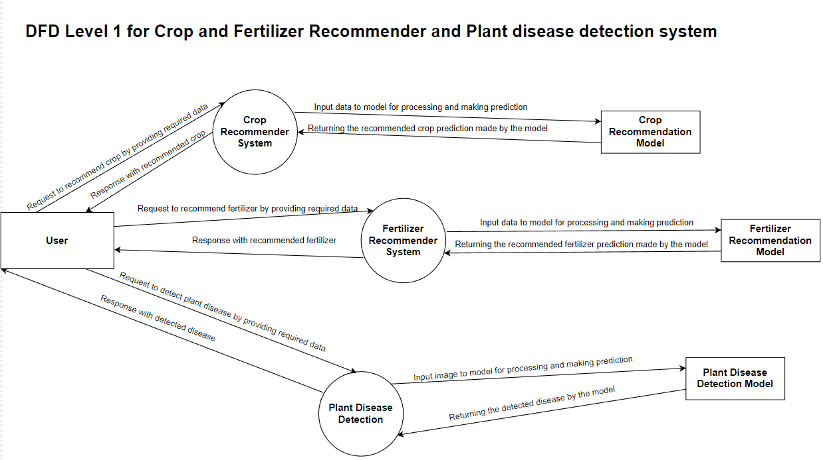

Fig 5.3 DFD level 1

The user provides soil and weather data to the model, which in turn feeds the crop recommendation system model which makes the prediction. Same happens in case of fertilizer recommendation system, just the user needs to input only the soil data. For the plant disease identification, a photo needs to be uploaded by the user which is fed into the model, and it classifies the disease. The solution is not integrated into the model itself, it would be externally integrated, as there was no dataset with inbuilt cures for the identified diseases present.

* + 1. Use case diagram

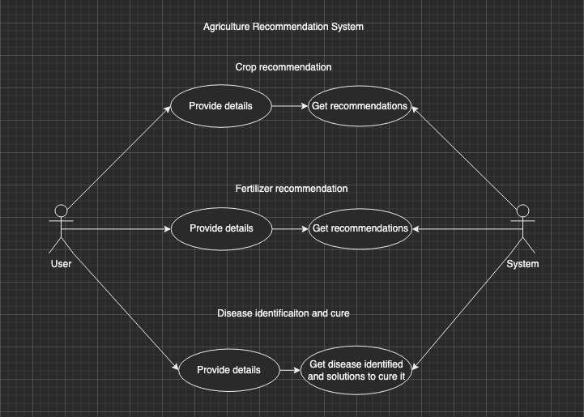

Fig 5.4 Use case diagram

Consider these following use cases:

1. User invokes Crop recommendation system:

In this case the user would be taken to the crop recommendation page and after that he can enter the required details. After the model receives all the details, the user is then brought to the result page, where the recommendation is being done.

1. User invokes Fertilizer recommendation system

In this case the user would be taken to the fertilizer recommendation page and after that he can enter the required details. After the model receives all the details, the user is then brought to the result page, where the recommendation is being done.

1. User invokes Crop disease identification system

In this case the user would be taken to the crop disease identification page and after that he needs to provide an image of the crop. After the model receives it, the user is then brought to the result page, where the identification is being done and the solution (cure) for the disease is also presented on the screen.

1. User invokes a mixture of any of these above systems

The user can use any of the above systems in any order and any number of times. He would just need to navigate to the proper page he needs. The navigation would be provided in the nav bar of the website for easier access. Once the request for any use case is taken, and the result is produces, none of that is saved anywhere. So the user can keep using the same feature repeatedly as well.

* + 1. Sequence diagram

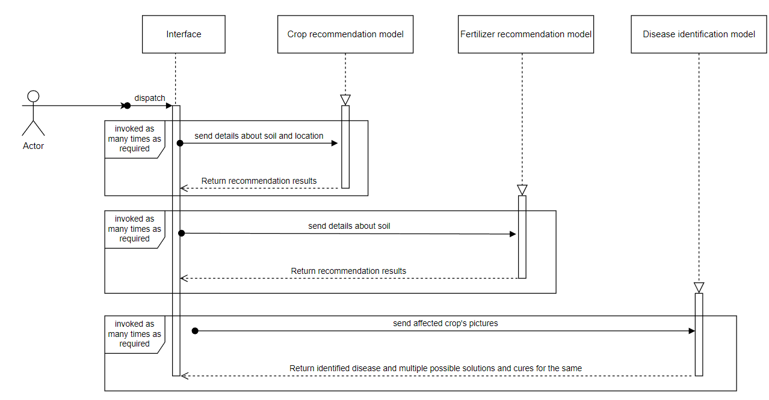

Fig 5.5 Sequence diagram

As explained in the use case diagram, a user can request for any of these services any number of times, the sequence diagram depicts three different models for the three aforementioned features. An interface keeps track of all requests and provides the result back to the user.

First, the user needs to initialize by entering the required details. After that these details are processed in the model and result is generated. This is the same sequence followed for all three features. The sequence in which the features would be use depends on the will of the user.

* + 1. Activity diagram

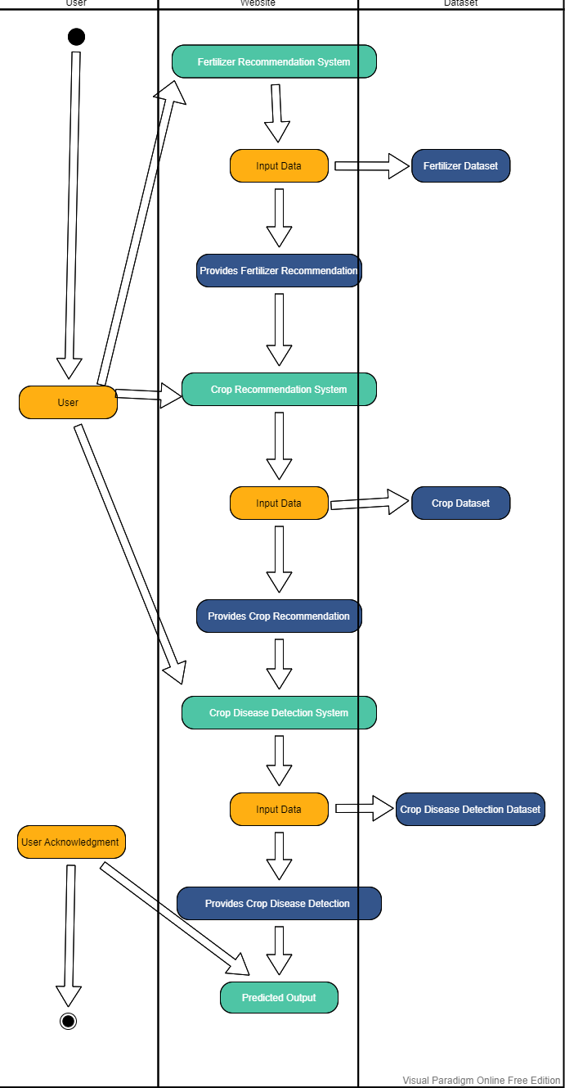

Fig 5.6 Activity diagram

* 1. **Implementation Details**

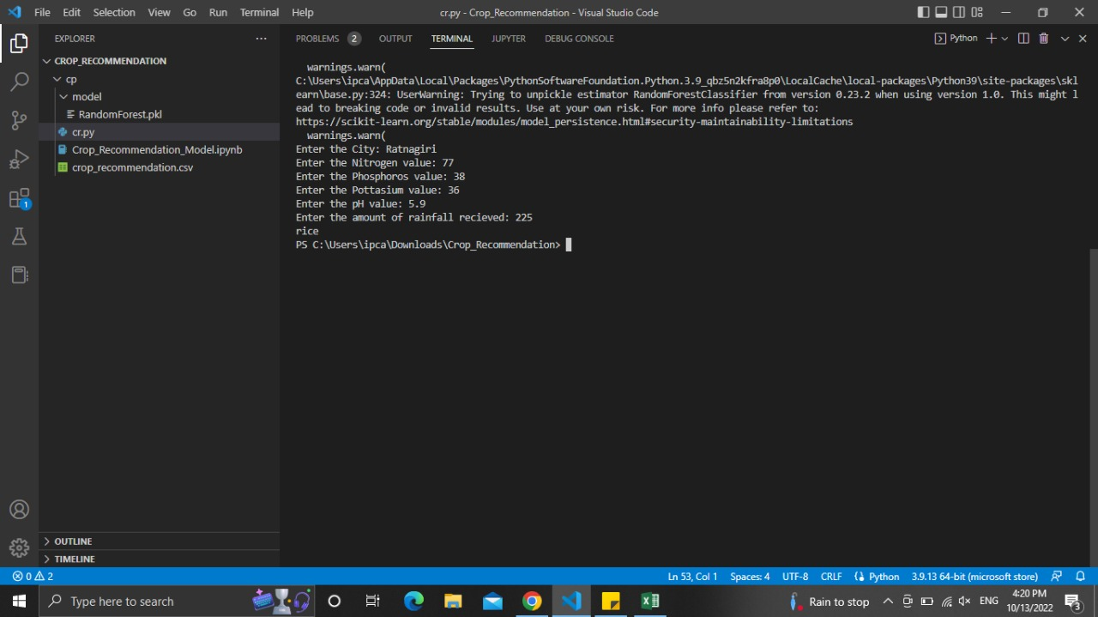

Fig 5.7 Implementation screenshot

**CHAPTER 6**

**Experimental Setup**

**Software requirements:**

1. Python 3.8 or higher
2. Numpy
3. Pandas
4. Scikit
5. Matplotlib
6. PyTorch
7. Flask

**Hardware Requirements:**

* 1. 8 / 16 GB RAM
  2. NVIDIA 1050 TI GPU

**CHAPTER 7**

**Project Plan**

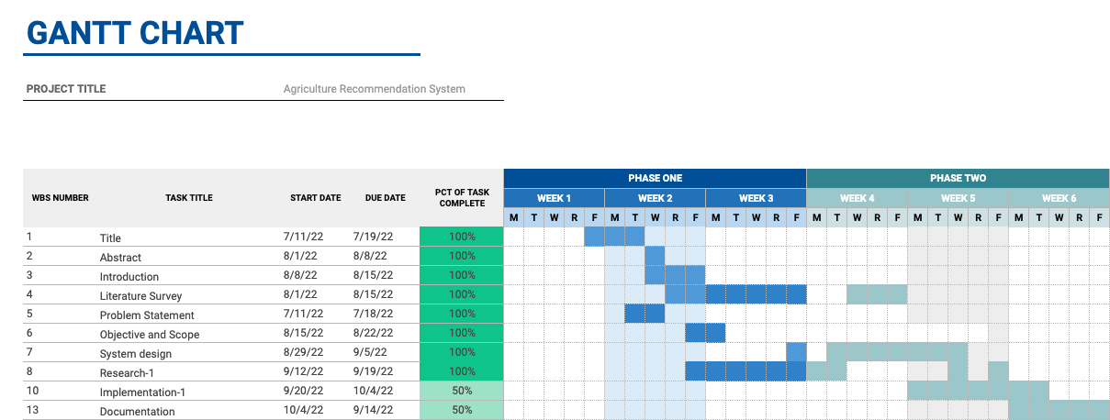

**Fig 7.1 Gantt Chart**

**CHAPTER 8**

**Expected Outcome**

The expected outcome for

1. Crop recommendation system: Should be able to predict the favourable crops according to soil and weather conditions within an acceptable accuracy range
2. Fertilizer recommendation system: Should be able to predict the favourable fertilizers according to soil conditions within an acceptable accuracy range
3. Crop Disease Classification system: Should be able to classify different crop disease using a photo and provide solutions for the same.

In addition to this, all these features would be in unified using a website which has a simple UI for naïve users.

**References**

[1] “Sector wise GDP of India”, <https://statisticstimes.com/economy/country/india-gdp-sectorwise.php>, sourced from [Ministry of Statistics and Programme Implementation](https://mospi.gov.in/documents/213904/416359/Press%20Note_31-05-2021_m1622547951213.pdf/7140019f-69b7-974b-2d2d-7630c3b0768d), 17th June, 2021.

[2] ﻿Manav Singhal, Kshitij Verma, Anupam Shukla, “Krishi Ville-Android based solution for Indian agriculture”, 2011 Fifth IEEE International Conference on Advanced Telecommunication Systems and Networks (ANTS), 18-21 Dec. 2011, Bangalore, India.

[3] Melike Sardogan, Adem Tuncer, Yunus Ozen, “Plant Leaf Disease Detection and Classification based on CNN with LVQ algorithm”, IEEE Xplore 2020.

[4] ﻿﻿Sharada P. Mohanty, David P. Hughes, and Marcel Salathé, “Using Deep Learning for

Image-Based Plant Disease Detection”, Frontiers in Plant Science Online Publication 2019, Switzerland.

[5] Sayed Mazhar Ali, Bhagwan Das, Dileep Kumar, ﻿“Machine Learning based Crop Recommendation System for Local Farmers of Pakistan”, A Research Gate Preprint Online Publication 2021, Pakistan.

[6] Dhruv Piyush Parikh, Jugal Jain, Tanishq Gupta, Rishit Hemant Dabhade, “﻿﻿Machine Learning Based Crop Recommendation System”, International Journal of Advanced Research in Science, Communication and Technology, 2021, Chennai, India.

[7] Pradeepa Bandara, Thilini Weerasooriya, Ruchirawya T.H., W.J.M. Nanayakkara, Dimantha M.A.C, Pabasara M.G.P., “Crop Recommendation System”, ﻿International Journal of Computer Applications (0975 – 8887) Volume 175– No. 22, October 2020.

# [8] Sunidhi N, Jalaja S, “AI Based Automatic Crop Disease Detection System”, IEEE Xplore 2021.

[9] V Rajesh Kumar, K Pradeepan, S Praveen, M Rohith, V Vasantha Kumar, “Identification of Plant Diseases Using Image Processing and Image Recognition”, IEEE Xplore 2021.